**C:\Users\V\AppData\Local\Temp\Rar$DRa0.667\kpi-tits\4.png**

**Міністерство освіти та науки України  
Національний технічний університет України  
«Київський політехнічний інститут»  
Факультет прикладної математики  
Кафедра системного програмування і спеціалізованих  
комп’ютерних систем**

**Лабораторна робота №2**з дисципліни

**«Схемотехніка»**Тема: **«Проектування тригерів на потенціальних елементах»**

Виконав: Вітовщик Михайло

Студент групи КВ-41

Перевірив(ла)________________________

**м. Київ**

**2016**

1.S-тригер на АБО-НЕ

|  |  |  |
| --- | --- | --- |
| S(t) | R(t) | Q(t+1) |
| 0 | 0 | Q(t) |
| 0 | 1 | 0 |
| 1 | 0 | 1 |
| 1 | 1 | 1 |

|  |  |  |  |
| --- | --- | --- | --- |
| Q(t) | Q(t+1) | F1 | F2 |
| 0 | 0 | * | 0 |
| 0 | 1 | 0 | 1 |
| 1 | 0 | 1 | 0 |
| 1 | 1 | 0 | * |

|  |  |  |  |  |  |  |
| --- | --- | --- | --- | --- | --- | --- |
| C | S | R | Q(t) | Q(t+1) | F1 | F2 |
| 0 | 0 | 0 | 0 | 0 | * | 0 |
| 0 | 0 | 0 | 1 | 1 | 0 | * |
| 0 | 0 | 1 | 0 | 0 | * | 0 |
| 0 | 0 | 1 | 1 | 1 | 0 | * |
| 0 | 1 | 0 | 0 | 0 | * | 0 |
| 0 | 1 | 0 | 1 | 1 | 0 | * |
| 0 | 1 | 1 | 0 | 0 | * | 0 |
| 0 | 1 | 1 | 1 | 1 | 0 | * |
| 1 | 0 | 0 | 0 | 0 | * | 0 |
| 1 | 0 | 0 | 1 | 1 | 0 | * |
| 1 | 0 | 1 | 0 | 0 | * | 0 |
| 1 | 0 | 1 | 1 | 0 | 1 | 0 |
| 1 | 1 | 0 | 0 | 1 | 0 | 1 |
| 1 | 1 | 0 | 1 | 1 | 0 | * |
| 1 | 1 | 1 | 0 | 1 | 0 | 1 |
| 1 | 1 | 1 | 1 | 1 | 0 | * |

|  |  |  |  |
| --- | --- | --- | --- |
| 0 | 0 | 0 | * |
| 0 | 0 | 1 | * |
| * | 0 | 0 | * |
| * | 0 | 0 | * |

|  |  |  |  |
| --- | --- | --- | --- |
| 1 | * | * | 0 |
| 1 | * | 0 | 0 |
| 0 | * | * | 0 |
| 0 | * | * | 0 |

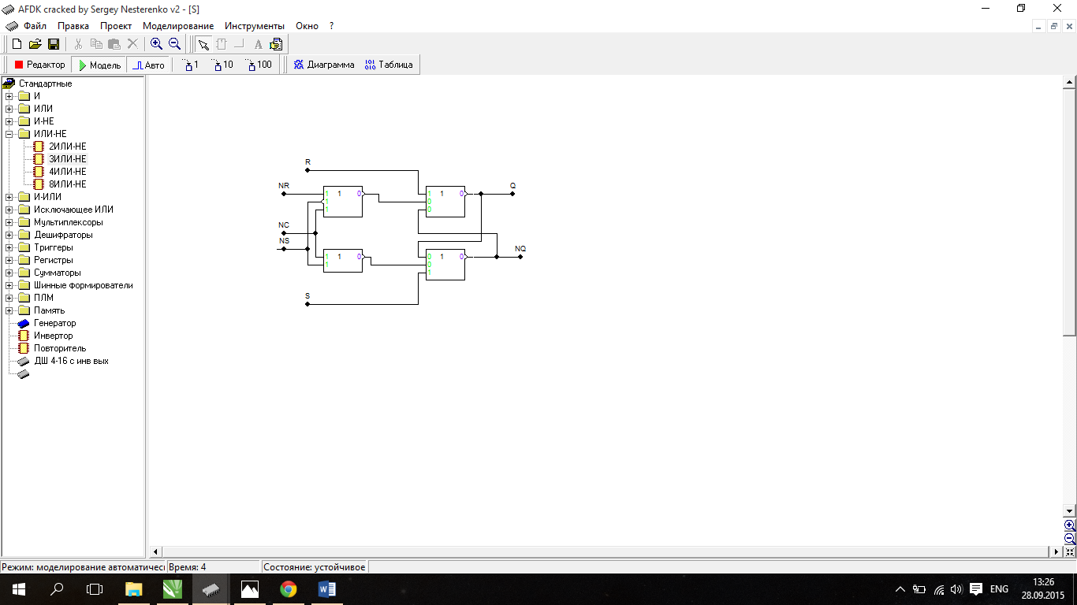

E-тригер на АБО-НЕ

|  |  |  |
| --- | --- | --- |
| S(t) | R(t) | Q(t+1) |
| 0 | 0 | Q(t) |
| 0 | 1 | 0 |
| 1 | 0 | 1 |
| 1 | 1 | Q(t) |

|  |  |  |  |
| --- | --- | --- | --- |
| Q(t) | Q(t+1) | F1 | F2 |
| 0 | 0 | * | 0 |
| 0 | 1 | 0 | 1 |
| 1 | 0 | 1 | 0 |
| 1 | 1 | 0 | * |

|  |  |  |  |  |  |  |
| --- | --- | --- | --- | --- | --- | --- |
| C | S | R | Q(t) | Q(t+1) | F1 | F2 |
| 0 | 0 | 0 | 0 | 0 | * | 0 |
| 0 | 0 | 0 | 1 | 1 | 0 | * |
| 0 | 0 | 1 | 0 | 0 | * | 0 |
| 0 | 0 | 1 | 1 | 1 | 0 | * |
| 0 | 1 | 0 | 0 | 0 | * | 0 |
| 0 | 1 | 0 | 1 | 1 | 0 | * |
| 0 | 1 | 1 | 0 | 0 | * | 0 |
| 0 | 1 | 1 | 1 | 1 | 0 | * |
| 1 | 0 | 0 | 0 | 0 | * | 0 |
| 1 | 0 | 0 | 1 | 1 | 0 | * |
| 1 | 0 | 1 | 0 | 0 | * | 0 |
| 1 | 0 | 1 | 1 | 0 | 1 | 0 |
| 1 | 1 | 0 | 0 | 1 | 0 | 1 |
| 1 | 1 | 0 | 1 | 1 | 0 | * |
| 1 | 1 | 1 | 0 | 0 | * | 0 |
| 1 | 1 | 1 | 1 | 1 | 0 | * |

|  |  |  |  |
| --- | --- | --- | --- |
| 0 | 0 | 0 | * |
| * | 0 | 1 | * |
| * | 0 | 0 | * |
| * | 0 | 0 | * |

|  |  |  |  |
| --- | --- | --- | --- |
| 1 | * | * | 0 |
| 0 | * | 0 | 0 |
| 0 | * | * | 0 |
| 0 | * | * | 0 |

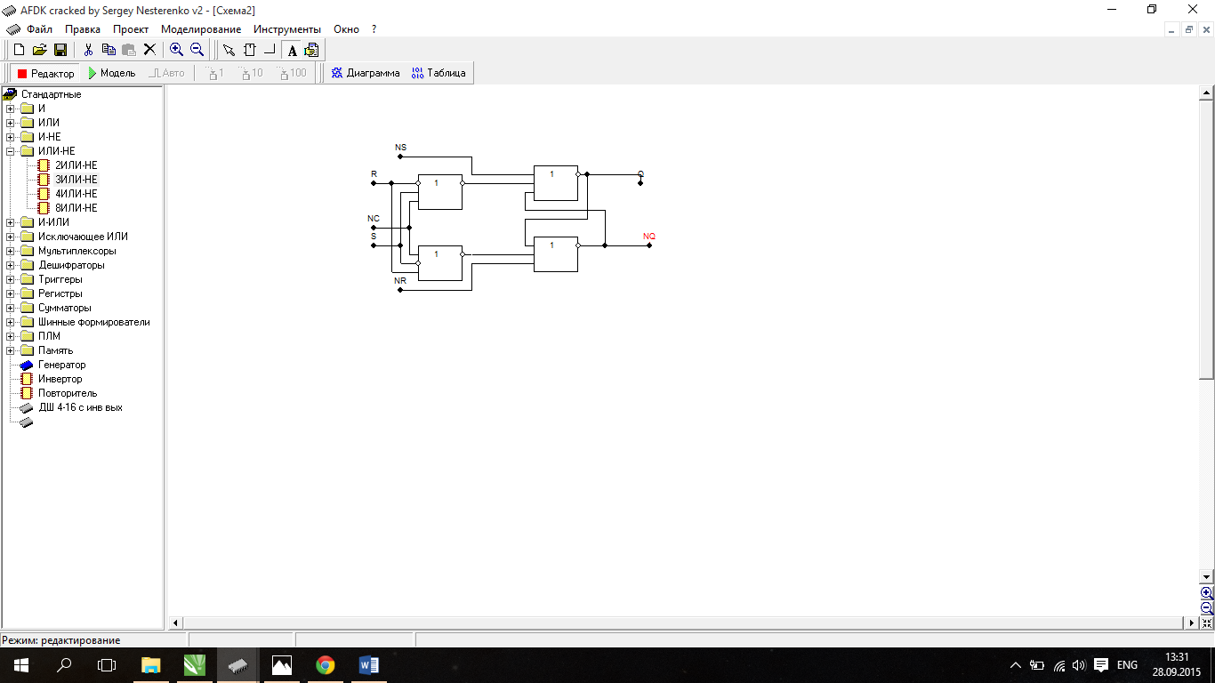

RS-тригер на І-НЕ

|  |  |  |
| --- | --- | --- |
| S(t) | R(t) | Q(t+1) |
| 0 | 0 | Q(t) |
| 0 | 1 | 0 |
| 1 | 0 | 1 |
| 1 | 1 | - |

|  |  |  |  |
| --- | --- | --- | --- |
| Q(t) | Q(t+1) | F1 | F2 |
| 0 | 0 | 1 | * |
| 0 | 1 | 0 | 1 |
| 1 | 0 | 1 | 0 |
| 1 | 1 | * | 1 |

|  |  |  |  |  |  |  |
| --- | --- | --- | --- | --- | --- | --- |
| C | S | R | Q(t) | Q(t+1) | F1 | F2 |
| 0 | 0 | 0 | 0 | 0 | 1 | * |
| 0 | 0 | 0 | 1 | 1 | * | 1 |
| 0 | 0 | 1 | 0 | 0 | 1 | * |
| 0 | 0 | 1 | 1 | 1 | * | 1 |
| 0 | 1 | 0 | 0 | 0 | 1 | * |
| 0 | 1 | 0 | 1 | 1 | * | 1 |
| 0 | 1 | 1 | 0 | 0 | 1 | * |
| 0 | 1 | 1 | 1 | 1 | * | 1 |
| 1 | 0 | 0 | 0 | 0 | 1 | * |
| 1 | 0 | 0 | 1 | 1 | * | 1 |
| 1 | 0 | 1 | 0 | 0 | 1 | * |
| 1 | 0 | 1 | 1 | 0 | 1 | 0 |
| 1 | 1 | 0 | 0 | 1 | 0 | 1 |
| 1 | 1 | 0 | 1 | 1 | * | 1 |
| 1 | 1 | 1 | 0 | -- | - | - |
| 1 | 1 | 1 | 1 | -- | - | - |

|  |  |  |  |
| --- | --- | --- | --- |
| 0 | * | * | 1 |
| - | - | 1 | 1 |
| 1 | * | * | 1 |
| 1 | * | * | 1 |

|  |  |  |  |
| --- | --- | --- | --- |
| 1 | 1 | 1 | * |
| - | - | 0 | * |
| * | 1 | 1 | * |
| * | 1 | 1 | * |

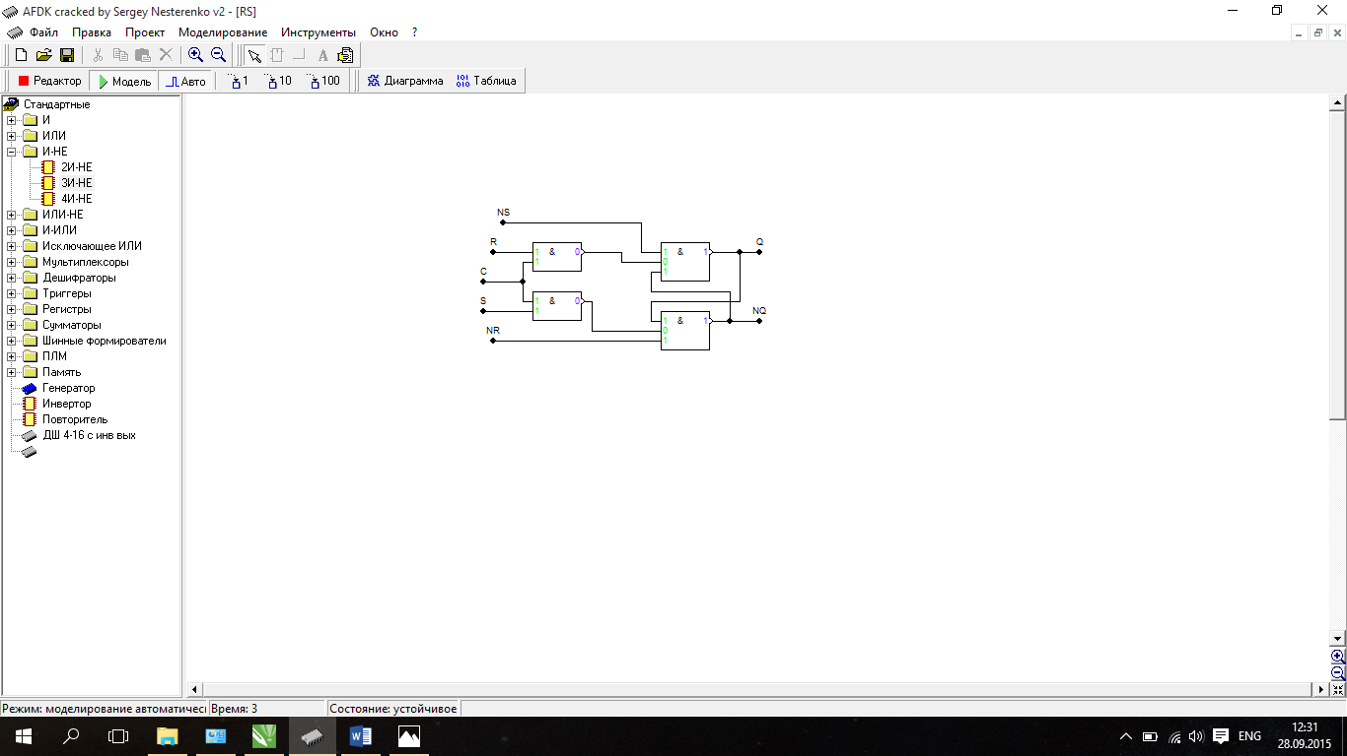

R-тригер на І-НЕ

|  |  |  |
| --- | --- | --- |
| S(t) | R(t) | Q(t+1) |
| 0 | 0 | Q(t) |
| 0 | 1 | 0 |
| 1 | 0 | 1 |
| 1 | 1 | 0 |

|  |  |  |  |
| --- | --- | --- | --- |
| Q(t) | Q(t+1) | F1 | F2 |
| 0 | 0 | 1 | * |
| 0 | 1 | 0 | 1 |
| 1 | 0 | 1 | 0 |
| 1 | 1 | * | 1 |

|  |  |  |  |  |  |  |
| --- | --- | --- | --- | --- | --- | --- |
| C | S | R | Q(t) | Q(t+1) | F1 | F2 |
| 0 | 0 | 0 | 0 | 0 | 1 | * |
| 0 | 0 | 0 | 1 | 1 | * | 1 |
| 0 | 0 | 1 | 0 | 0 | 1 | * |
| 0 | 0 | 1 | 1 | 1 | * | 1 |
| 0 | 1 | 0 | 0 | 0 | 1 | * |
| 0 | 1 | 0 | 1 | 1 | * | 1 |
| 0 | 1 | 1 | 0 | 0 | 1 | * |
| 0 | 1 | 1 | 1 | 1 | * | 1 |
| 1 | 0 | 0 | 0 | 0 | 1 | * |
| 1 | 0 | 0 | 1 | 1 | * | 1 |
| 1 | 0 | 1 | 0 | 0 | 1 | * |
| 1 | 0 | 1 | 1 | 0 | 1 | 0 |
| 1 | 1 | 0 | 0 | 1 | 0 | 1 |
| 1 | 1 | 0 | 1 | 1 | * | 1 |
| 1 | 1 | 1 | 0 | 0 | 1 | * |
| 1 | 1 | 1 | 1 | 0 | 1 | 0 |

|  |  |  |  |
| --- | --- | --- | --- |
| 0 | * | * | 1 |
| 1 | 1 | 1 | 1 |
| 1 | * | * | 1 |
| 1 | * | * | 1 |

|  |  |  |  |
| --- | --- | --- | --- |
| 1 | 1 | 1 | * |
| * | 0 | 0 | * |
| * | 1 | 1 | * |
| * | 1 | 1 | * |

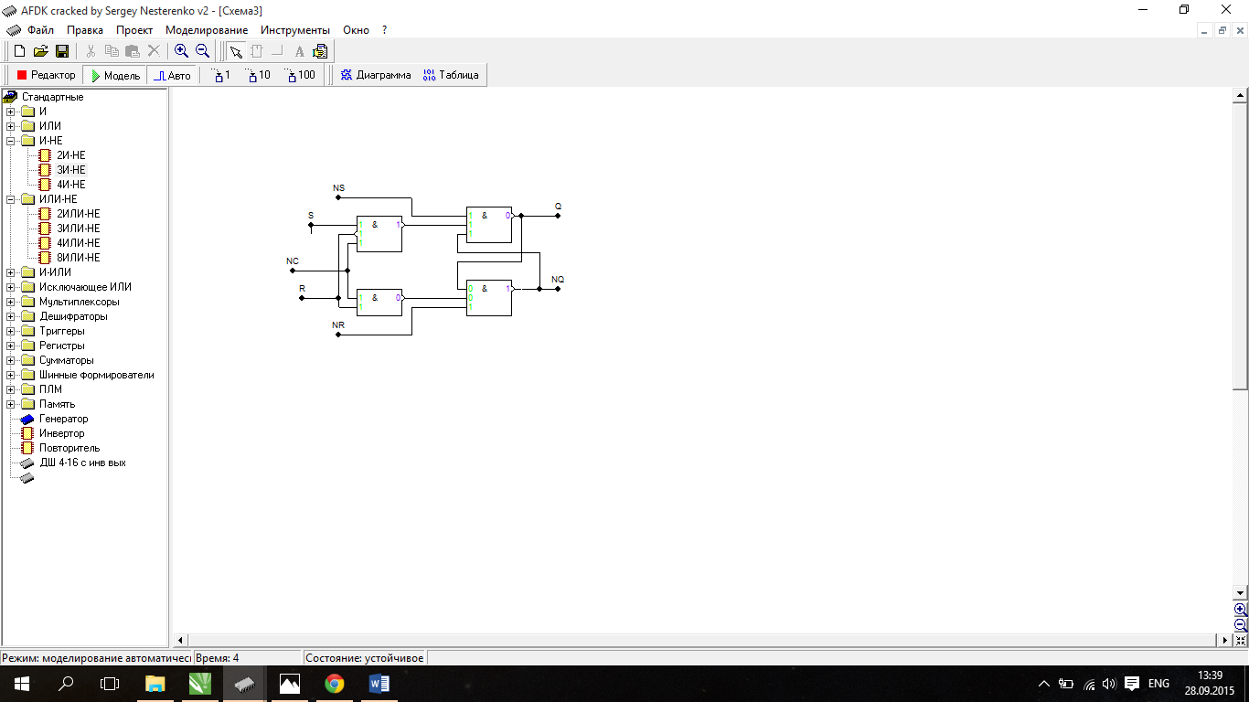

2.D-тригер за MS схемою І-не

|  |  |
| --- | --- |
| D(t) | Q(t+1) |
| 0 | 0 |
| 1 | 1 |

|  |  |  |  |
| --- | --- | --- | --- |
| Q(t) | Q(t+1) | F1 | F2 |
| 0 | 0 | 1 | * |
| 0 | 1 | 0 | 1 |
| 1 | 0 | 1 | 0 |
| 1 | 1 | * | 1 |

|  |  |  |  |  |  |
| --- | --- | --- | --- | --- | --- |
| C | D | Q(t) | Q(t+1) | F1 | F2 |
| 0 | 0 | 0 | 0 | 1 | * |
| 0 | 0 | 1 | 1 | * | 1 |
| 0 | 1 | 0 | 0 | 1 | * |
| 0 | 1 | 1 | 1 | * | 1 |
| 1 | 0 | 0 | 0 | 1 | * |
| 1 | 0 | 1 | 0 | 1 | 0 |
| 1 | 1 | 0 | 1 | 0 | 1 |
| 1 | 1 | 1 | 1 | * | 1 |

|  |  |  |  |
| --- | --- | --- | --- |
| 0 | * | 1 | 1 |
| 1 | * | * | 1 |

|  |  |  |  |
| --- | --- | --- | --- |
| 1 | 1 | 0 | * |
| * | 1 | 1 | * |

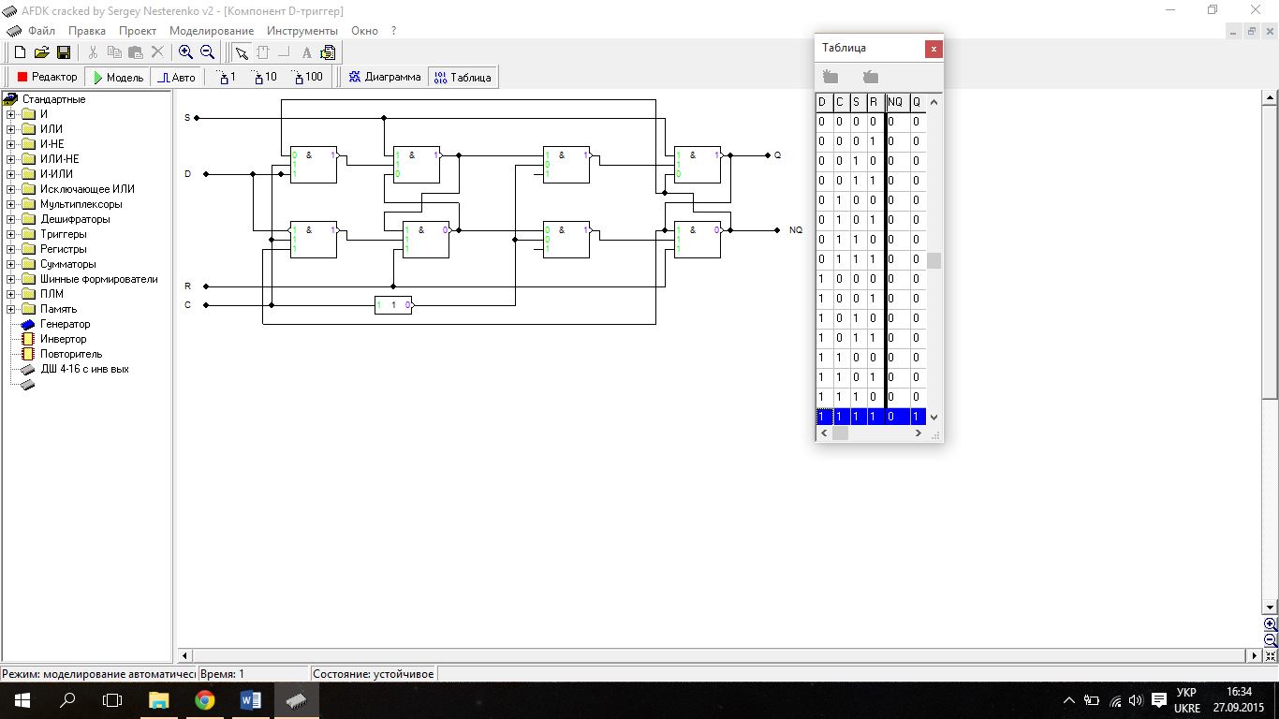

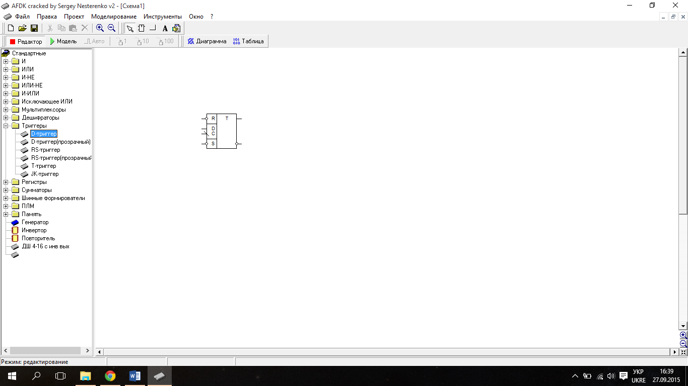

JK-тригер MS на I-НЕ

|  |  |  |
| --- | --- | --- |
| J(t) | K(t) | Q(t+1) |
| 0 | 0 | Q(t) |
| 0 | 1 | 0 |
| 1 | 0 | 1 |
| 1 | 1 | NQ(t) |

|  |  |  |  |
| --- | --- | --- | --- |
| Q(t) | Q(t+1) | F1 | F2 |
| 0 | 0 | 1 | * |
| 0 | 1 | 0 | 1 |
| 1 | 0 | 1 | 0 |
| 1 | 1 | * | 1 |

|  |  |  |  |  |  |  |
| --- | --- | --- | --- | --- | --- | --- |
| C | J | K | Q(t) | Q(t+1) | F1 | F2 |
| 0 | 0 | 0 | 0 | 0 | 1 | * |
| 0 | 0 | 0 | 1 | 1 | * | 1 |
| 0 | 0 | 1 | 0 | 0 | 1 | * |
| 0 | 0 | 1 | 1 | 1 | * | 1 |
| 0 | 1 | 0 | 0 | 0 | 1 | * |
| 0 | 1 | 0 | 1 | 1 | * | 1 |
| 0 | 1 | 1 | 0 | 0 | 1 | * |
| 0 | 1 | 1 | 1 | 1 | * | 1 |
| 1 | 0 | 0 | 0 | 0 | 1 | * |
| 1 | 0 | 0 | 1 | 1 | * | 1 |
| 1 | 0 | 1 | 0 | 0 | 1 | * |
| 1 | 0 | 1 | 1 | 0 | 1 | 0 |
| 1 | 1 | 0 | 0 | 1 | 0 | 1 |
| 1 | 1 | 0 | 1 | 1 | * | 1 |
| 1 | 1 | 1 | 0 | 1 | 0 | 1 |
| 1 | 1 | 1 | 1 | 0 | 1 | 0 |

|  |  |  |  |
| --- | --- | --- | --- |
| 0 | * | * | 1 |
| 0 | 1 | 1 | 1 |
| 1 | * | * | 1 |
| 1 | * | * | 1 |

|  |  |  |  |
| --- | --- | --- | --- |
| 1 | 1 | 1 | * |
| 1 | 0 | 0 | * |
| * | 1 | 1 | * |
| * | 1 | 1 | * |

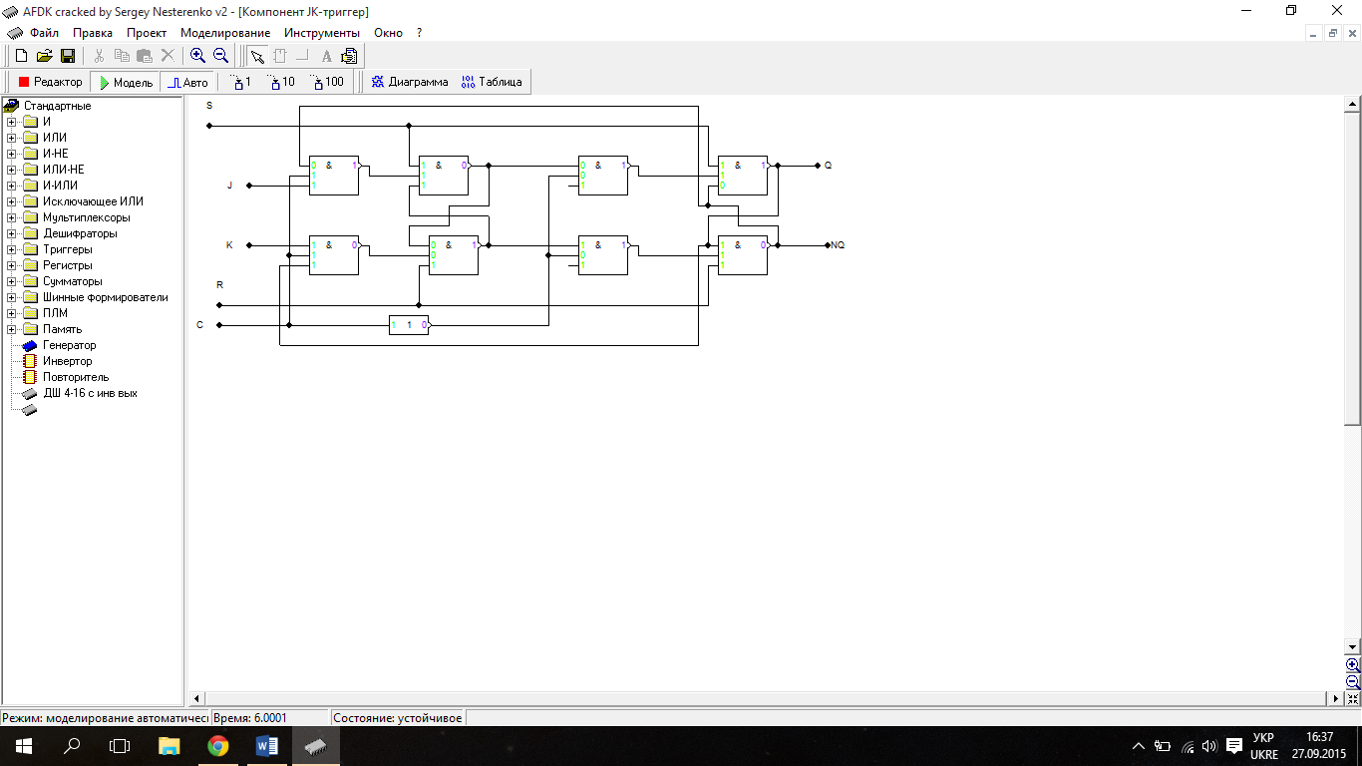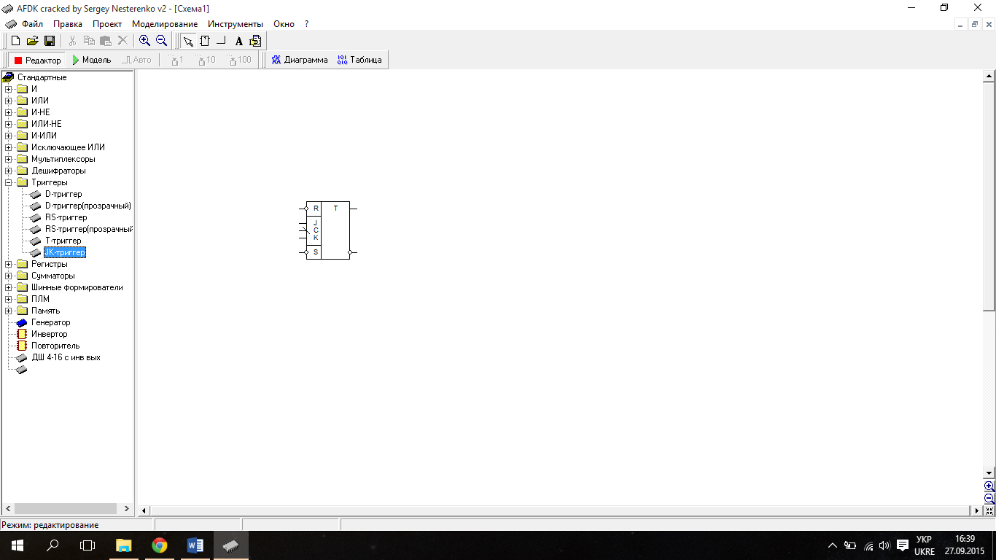

Т-тригер за MS схемою АБО-НЕ

|  |  |
| --- | --- |
| Т(t) | Q(t+1) |
| 0 | Q(t) |
| 1 | NQ(t) |

|  |  |  |  |
| --- | --- | --- | --- |
| Q(t) | Q(t+1) | F1 | F2 |
| 0 | 0 | * | 0 |
| 0 | 1 | 0 | 1 |
| 1 | 0 | 1 | 0 |
| 1 | 1 | 0 | * |

|  |  |  |  |  |  |
| --- | --- | --- | --- | --- | --- |
| C | T | Q(t) | Q(t+1) | F1 | F2 |
| 0 | 0 | 0 | 0 | * | 0 |
| 0 | 0 | 1 | 1 | 0 | * |
| 0 | 1 | 0 | 0 | * | 0 |
| 0 | 1 | 1 | 1 | 0 | * |
| 1 | 0 | 0 | 0 | * | 0 |
| 1 | 0 | 1 | 1 | 0 | * |
| 1 | 1 | 0 | 1 | 0 | 1 |
| 1 | 1 | 1 | 0 | 1 | 0 |

|  |  |  |  |
| --- | --- | --- | --- |
| 0 | 1 | 0 | * |
| * | 0 | 0 | * |

|  |  |  |  |
| --- | --- | --- | --- |
| 1 | 0 | * | 0 |
| 0 | * | * | 0 |

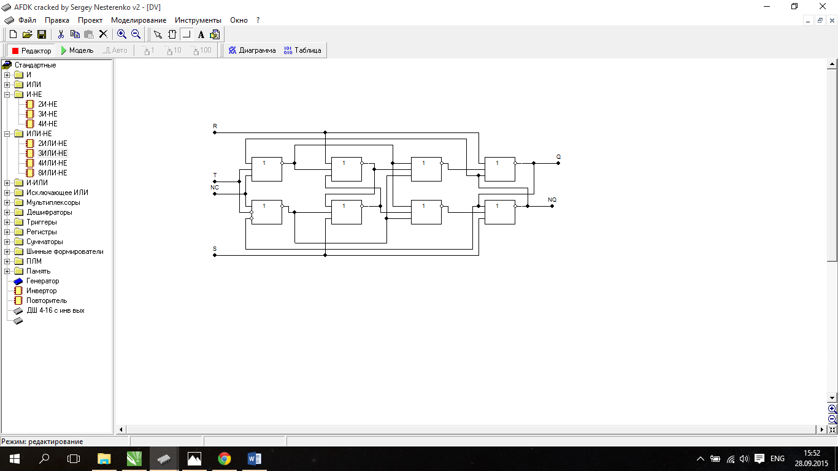

DV-тригер MS на АБО-НЕ

|  |  |  |
| --- | --- | --- |
| J(t) | K(t) | Q(t+1) |
| 0 | 0 | Q(t) |
| 0 | 1 | Q(t) |
| 1 | 0 | 0 |
| 1 | 1 | 1 |

|  |  |  |  |
| --- | --- | --- | --- |
| Q(t) | Q(t+1) | F1 | F2 |
| 0 | 0 | * | 0 |
| 0 | 1 | 0 | 1 |
| 1 | 0 | 1 | 0 |
| 1 | 1 | 0 | * |

|  |  |  |  |  |  |  |
| --- | --- | --- | --- | --- | --- | --- |
| C | D | V | Q(t) | Q(t+1) | F1 | F2 |
| 0 | 0 | 0 | 0 | 0 | * | 0 |
| 0 | 0 | 0 | 1 | 1 | 0 | * |
| 0 | 0 | 1 | 0 | 0 | * | 0 |
| 0 | 0 | 1 | 1 | 1 | 0 | * |
| 0 | 1 | 0 | 0 | 0 | * | 0 |
| 0 | 1 | 0 | 1 | 1 | 0 | * |
| 0 | 1 | 1 | 0 | 0 | * | 0 |
| 0 | 1 | 1 | 1 | 1 | 0 | * |
| 1 | 0 | 0 | 0 | 0 | * | 0 |
| 1 | 0 | 0 | 1 | 1 | 0 | * |
| 1 | 0 | 1 | 0 | 0 | * | 0 |
| 1 | 0 | 1 | 1 | 1 | 0 | * |
| 1 | 1 | 0 | 0 | 0 | * | 0 |
| 1 | 1 | 0 | 1 | 0 | 1 | 0 |
| 1 | 1 | 1 | 0 | 1 | 0 | 1 |
| 1 | 1 | 1 | 1 | 1 | 0 | * |

|  |  |  |  |
| --- | --- | --- | --- |
| * | 1 | 0 | * |
| 0 | 0 | 0 | * |
| * | 0 | 0 | * |
| * | 0 | 0 | * |

|  |  |  |  |
| --- | --- | --- | --- |
| 0 | 0 | * | 0 |
| 1 | * | * | 0 |
| 0 | * | * | 0 |
| 0 | * | * | 0 |

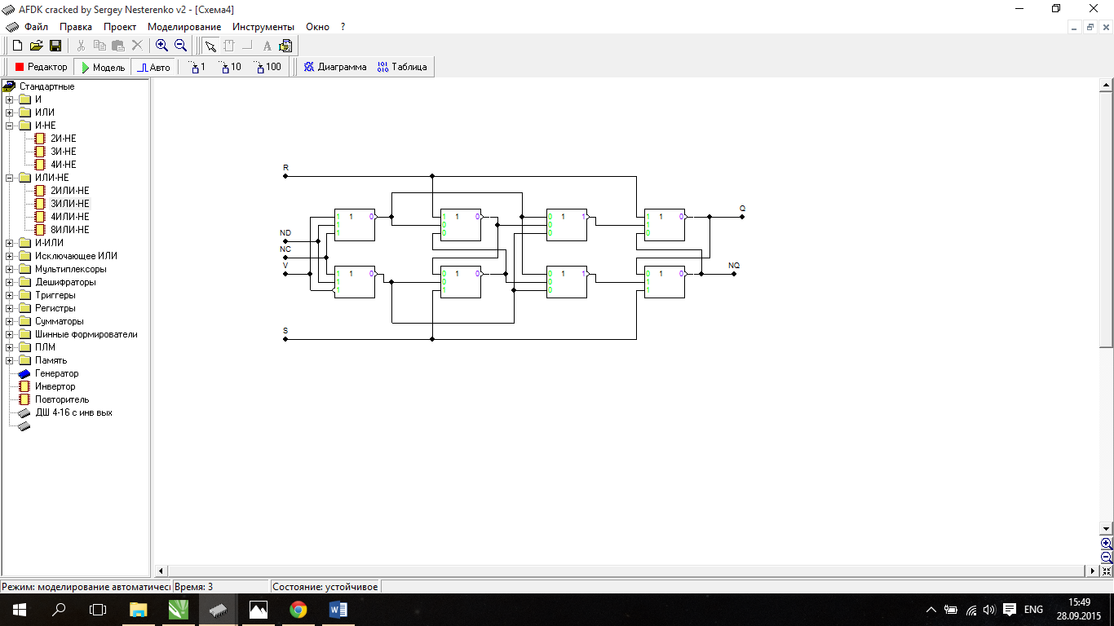

3.Тригер на трьох бістабільних схемаx на елементах АБО-НЕ

|  |  |  |  |
| --- | --- | --- | --- |
| Q(t) | Q(t+1) | F1 | F2 |
| 0 | 0 | * | 0 |
| 0 | 1 | 0 | 1 |
| 1 | 0 | 1 | 0 |
| 1 | 1 | 0 | * |

|  |  |  |
| --- | --- | --- |
| X1 | X2 | Q(t+1) |
| 0 | 0 | 0 |
| 0 | 1 | 1 |
| 1 | 0 | Q(t) |
| 1 | 1 | NQ(t) |

|  |  |  |  |  |  |  |
| --- | --- | --- | --- | --- | --- | --- |
| C | X1 | X2 | Q(t) | Q(t+1) | F1 | F2 |
| 0 | 0 | 0 | 0 | 0 | * | 0 |
| 0 | 0 | 0 | 1 | 1 | 0 | * |
| 0 | 0 | 1 | 0 | 0 | * | 0 |
| 0 | 0 | 1 | 1 | 1 | 0 | * |
| 0 | 1 | 0 | 0 | 0 | * | 0 |
| 0 | 1 | 0 | 1 | 1 | 0 | * |
| 0 | 1 | 1 | 0 | 0 | * | 0 |
| 0 | 1 | 1 | 1 | 1 | 0 | * |
| 1 | 0 | 0 | 0 | 0 | * | 0 |
| 1 | 0 | 0 | 1 | 0 | 1 | 0 |
| 1 | 0 | 1 | 0 | 1 | 0 | 1 |
| 1 | 0 | 1 | 1 | 1 | 0 | * |
| 1 | 1 | 0 | 0 | 0 | * | 0 |
| 1 | 1 | 0 | 1 | 1 | 0 | * |
| 1 | 1 | 1 | 0 | 1 | 0 | 1 |
| 1 | 1 | 1 | 1 | 0 | 1 | 0 |

|  |  |  |  |
| --- | --- | --- | --- |
| 1 | 1 | * | 1 |
| 0 | * | 1 | 0 |
| 1 | * | * | 1 |
| 1 | * | * | 1 |

|  |  |  |  |
| --- | --- | --- | --- |
| * | 0 | 1 | * |
| 1 | 1 | 0 | 1 |
| * | 1 | 1 | * |
| * | 1 | 1 | * |

F1 = CX1X2Q v CNX1NX2

F2 = CX1X2NQ v CNX1X2

